
Essex Day Festival VENDOR APPLICATION
Saturday Sept. 19, 2026 from 11 am to 5 pm
400-600 Blocks Eastern Blvd.
Check One | Type of Vendor | Fee per space | # of spaces | TOTAL FEE
 | Multi-Food or Food Truck: early bird $250 on or before Aug. 1. $275 after.
 | Single Food vendor: early bird $125 on or before Aug. 1. $150 after.
 | Ice cream/Snowballs: early bird $125 on or before Aug. 1. $150 after.
 | Political: early bird $100 on or before Aug. 1. $125 after.
 | Craft/retail: early bird $75 on or before Aug. 1. $100 after.
Non-profits: early bird $25 on or before Aug. 1. $50 after.
Non-Profits MUST provide proof of non-profit status.

*****MUST complete this section or your application will not be approved: Please provide a description of your
business (clothing, jewelry, crafts, etc.) or non-profit IRS Number: _____________________________________________
Each space is approximately 15’ wide X 10’ deep. Tents and tables MUST fit into this footprint. Electricity WILL NOT be provided. We will attempt to accommodate special location requests but cannot guarantee.
Note Space Location Request: _________________________________________________________________________
Size of canopy/tent or truck _____________ Generator: ______ Y ______ N
Type of Generator* ______________________ * Decibel level will be tested on site.
CONTACT INFORMATION (Please list name as it should appear in any promotions):
Contact Name:
Vendor/Business Name:
If you represent a Direct Sales Company, list it here:
Address:
City/State/Zip:
Phone:
Email:

There is no rain date for this event and no refunds.
Please send completed application and payment (payable to Essex Day Festival) to P.O. Box 7753, Essex, MD 21221 OR drop off at mail slot at the Heritage Society of Essex and Middle River (museum/historic fire station next to CVS), 516 Eastern Blvd. Electronic payment may be sent via PayPal to The New Essex Day Festival Assoc., Inc. (essexdayfestival@gmail.com). Signed application AND payment must be received for vendor consideration. For more information contact us at 443-579-4913 or essexdayfestival@gmail.com.
I agree to hold harmless and indemnify The Essex Day Festival and The New Essex Day Festival Association, Inc. and/or its sponsors from any loss of property, and/or personal injury suffered during our participation in the festival. I agree to accept and abide by all the rules set forth by The New Essex Day Festival Association, Inc. both in this contract and the attached list of terms and conditions.

Signature: ________________________________________________________ Date: __________________________

Essex Day Festival VENDOR TERMS & CONDITIONS
Take advantage of EARLY BIRD pricing and return your application and payment before Sat., August 1, 2026. You have 3 options:
- PREFERRED PAYMENT is PayPal: Go to PayPal.com. Log in or sign up for an account. Send fees to The New Essex Day Festival Assoc., Inc. (essexdayfestival@gmail.com) AND email us your application to same email.
- Deliver to mail slot at the Heritage Society of Essex and Middle River (old fire station next to CVS), 516 Eastern Blvd.
- Mail check/money order WITH application to P.O. Box. 7753, Essex, MD 21221.
Please note: The committee must approve your application, and just because you put in an application does not mean you’re approved to be a vendor at Essex Day. You will receive a confirmation email after your application is approved. Please allow approximately 2 weeks from application submission. All approved vendors will be listed alphabetically on our website, www.essexdayfestival.com. Space assignments will be sent out the week of the event. If you have any questions about your vendor status, please contact us at 443-579-4913. If you are approved, FEES ARE NON-REFUNDABLE.
All vendors will be held accountable to adhere to the terms and conditions listed below:
- Midway opens for set-up at 8:00 a.m. on 9/19. ALL vendors must enter via S. Taylor Avenue. Enter midway and unload your vehicle at your assigned space. You must remain open at your spot until closing at 5:00 p.m. We will do a check in the afternoon and note of vendors who leave early and take this into account when accepting vendors the following year.
- Vehicles are not permitted on the Midway after 10:00 a.m. or before 5:00 p.m. After unloading, move your vehicle to a parking spot in the neighborhood.
- Spaces guaranteed up to 15 ft. wide & 10 ft. deep. Vendors must supply their own tables, chairs, tents and trash containers. These all must fit into the 15’ X 10’ footprint.
- NO ELECTRICITY is provided. If you will be using a generator you must note that on your application. Festival Committee must approve your generator. Decibel levels will be tested and must be at 85 or below measured from a 5-foot distance.
- The Association has the right to restrict the sale of any item that may be considered harmful, destructive or not in the best interest of the image of the Essex Day Festival. NO WEAPONS may be sold.
- DIRECT SALES/MLM VENDORS: We accept a maximum of 2 of each type of direct sales/MLM vendor. Spots are first come, first served for those paid in full. We understand direct sales/MLM vendors are subject to the guidelines of their parent organizations and affiliates. We do not determine or enforce these policies.
- You must leave your space clean and free of debris. Food vendors using any products such as grease MUST remove it from the site before leaving the Midway. A dumpster for vendor use will be available. Dumpster details will be sent at a later date.
DO NOT LEAVE TRASH BAGS AT YOUR SPACE.
- Only approved food and beverage vendors may sell food and beverages, including soda and water (NO GLASS). No other vendors may sell or give away food or beverages.
- ALCOHOLIC BEVERAGES MAY NOT BE BROUGHT IN OR SOLD ON THE MIDWAY.
- FOOD VENDORS: You are responsible to obtain food permit and be approved by Baltimore County Health Department. Call 410-887-3663. You MUST display food permit on day of festival (MANDATORY).
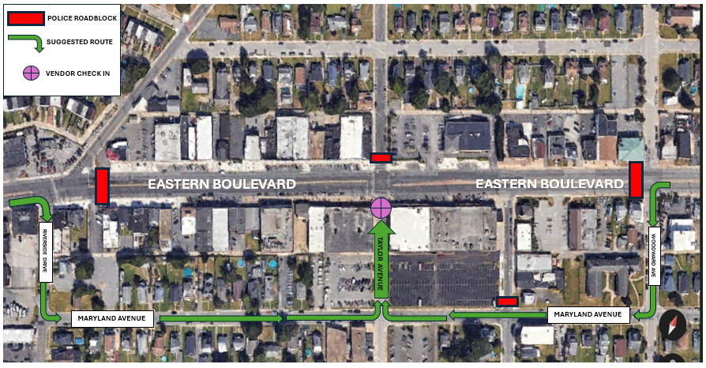
- If you have an issue on event day, please contact one of our volunteer staff. Only our staff can assign or change spaces.
Arrival Map:
Vendors must access their vendor spots via South Taylor Ave. (green arrows). For your safety and the safety of others, please follow directions from our volunteer staff!

